# Introduction

This research aims to discuss who wrote the disputed essays in the federalist papers. Could it be Hamilton or Madison? The Federalist Papers were a series of eighty-five essays urging the citizens of New York to ratify the new United States Constitution. Written by Alexander Hamilton, James Madison, and John Jay, the essays originally appeared anonymously in New York newspapers in 1787 and 1788 under the pen name "Publius." Abound edition of the essays was first published in 1788, but it was not until the 1818 edition published by the printer Jacob Gideon that the authors of each essay were identified by name. The Federalist Papers are considered one of the most important sources for interpreting and understanding the original intent of the Constitution.

From 74 essays, the identified authors are 51 essays written by Hamilton, 15 by Madison, 3 by Hamilton, and Madison, 5 by Jay. The remaining 11 essays, however, are authored by “Hamilton or Madison”. The essays authored by Hamilton or Madison are shown appendix A. The numbers of the essays are 49, 50, 51, 52, 53, 54, 55, 56, 57, 62, and 63. This research will analyze the data set and use cluster algorithms including k-Means, EM, and HAC to conclude who wrote the disputed essays.

# Analysis and Models

The researcher will present the process of analyzing the federalist paper data set in this section.

### Loading Libraries

We will use many libraries to assist with our analysis. The packages include natural language processing, clustering, matrix, visualization, etc. The packages used are crucial to complete the analysis and gain insights.

library(tm)

library(slam)

library(quanteda)

library(SnowballC)

library(arules)

library(proxy)

library(cluster)

library(stringi)

library(Matrix)

library(tidytext)

library(plyr)

library(ggplot2)

library(factoextra)

library(mclust)

library(dplyr)

library(wordcloud)

library(factoextra)

### Loading Data

In linguistics, a corpus or text corpus is a large and structured set of texts. In corpus linguistics, they are used to do statistical analysis and hypothesis testing, checking occurrences or validating linguistic rules within a specific language territory. The researcher was provided with a corpus for the analysis.

###Load Fed Papers Corpus  
FedPapersCorpus <- Corpus(DirSource("FedPapersCorpus"))

numberFedPapers <- length(FedPapersCorpus)  
numberFedPapers

## [1] 85

##The following will show you that you read in all the documents  
(summary(FedPapersCorpus))

## Length Class Mode  
## dispt_fed_49.txt 2 PlainTextDocument list  
## dispt_fed_50.txt 2 PlainTextDocument list  
## dispt_fed_51.txt 2 PlainTextDocument list  
## dispt_fed_52.txt 2 PlainTextDocument list  
## dispt_fed_53.txt 2 PlainTextDocument list  
…

…  
## Madison_fed_45.txt 2 PlainTextDocument list  
## Madison_fed_46.txt 2 PlainTextDocument list  
## Madison_fed_47.txt 2 PlainTextDocument list  
## Madison_fed_48.txt 2 PlainTextDocument list  
## Madison_fed_58.txt 2 PlainTextDocument list

### Data Cleaning

In this section, we are going to do data cleaning. The data cleaning steps include 1. Removing punctuation, numbers, and space 2. Ignore extremely rare words. We used one percent as the benchmark. The words that appeared less than one percent are removed. 3. Ignore commonly used words. We used fifty percent as the benchmark. The words that appeared more than fifty percent are removed. 4. Exclude stop words - stop words are words that are filtered out before or after processing of natural language data. The cleaning steps executed will provide a better picture by removing bias.

##Data Preparation and Transformation on Fed Papers  
###Remove punctuation,numbers, and space   
(getTransformations())

## [1] "removeNumbers" "removePunctuation" "removeWords"   
## [4] "stemDocument" "stripWhitespace"

(nFedPapersCorpus<-length(FedPapersCorpus))

## [1] 85

### ignore extremely rare words i.e. terms that appear in less then 1% of the documents  
(minTermFreq <- nFedPapersCorpus * 0.0001)

## [1] 0.0085

###Ignore overly common words i.e. terms that appear in more than 50% of the documents  
(maxTermFreq <- nFedPapersCorpus * 1)

## [1] 85

(MyStopwords <- c("will","one","two", "may","less", "well","might","withou","small", "single", "several", "but", "very", "can", "must", "also", "any", "and", "are", "however", "into", "almost", "can","for", "add" ))

## [1] "will" "one" "two" "may" "less" "well" "might"   
## [8] "withou" "small" "single" "several" "but" "very" "can"   
## [15] "must" "also" "any" "and" "are" "however" "into"   
## [22] "almost" "can" "for" "add"

#stopwords  
(STOPS <-stopwords('english'))

## [1] "i" "me" "my" "myself" "we"   
## [6] "our" "ours" "ourselves" "you" "your"   
## [11] "yours" "yourself" "yourselves" "he" "him"   
## [16] "his" "himself" "she" "her" "hers"   
## [21] "herself" "it" "its" "itself" "they"   
## [26] "them" "their" "theirs" "themselves" "what"   
…

…  
## [171] "so" "than" "too" "very" "will"

Papers_DTM <- DocumentTermMatrix(FedPapersCorpus,  
 control = list(  
 stopwords = TRUE,   
 wordLengths=c(3, 15),  
 removePunctuation = T,  
 removeNumbers = T,  
 tolower=T,  
 stemming = T,  
 remove_separators = T,  
 stopwords = MyStopwords,  
 bounds = list(global = c(minTermFreq,maxTermFreq))))  
  
#inspect FedPapers Document Term Matrix (DTM)  
DTM <- as.matrix(Papers_DTM)  
(DTM[1:11,1:10])

## Terms  
## Docs abandon abat abb abet abhorr abil abject abl ablest abolish  
## dispt_fed_49.txt 0 0 0 0 0 0 0 2 0 0  
## dispt_fed_50.txt 0 0 0 0 0 0 0 0 0 0  
## dispt_fed_51.txt 0 0 0 0 0 0 0 1 0 0  
## dispt_fed_52.txt 0 0 0 0 0 1 0 1 0 0  
## dispt_fed_53.txt 0 1 0 0 0 0 0 0 0 0  
## dispt_fed_54.txt 0 0 0 0 0 0 0 0 0 0  
## dispt_fed_55.txt 0 0 0 0 0 0 0 0 0 0  
## dispt_fed_56.txt 0 0 0 0 0 0 0 0 0 0  
## dispt_fed_57.txt 0 0 0 0 1 0 0 0 0 0  
## dispt_fed_62.txt 0 0 0 0 0 0 0 1 0 0  
## dispt_fed_63.txt 0 0 0 0 0 0 0 4 0 0

### Initial Cleaning Results

This section presents the results of data cleaning. There are 4900 words. The word frequencies are stored in WordFreq vector. The row rums per Fed paper present the collective result of word frequencies in each file.

## Look at word frequencies  
WordFreq <- colSums(as.matrix(Papers_DTM))  
(head(WordFreq))

## abandon abat abb abet abhorr abil   
## 9 2 5 2 1 15

(length(WordFreq))

## [1] 4900

ord <- order(WordFreq)  
(WordFreq[head(ord)])

## abhorr abject abraham abreg absenc absolv   
## 1 1 1 1 1 1

(WordFreq[tail(ord)])

## constitut may power govern will state   
## 686 811 937 1040 1263 1662

## Row Sums per Fed Papers  
(Row_Sum_Per_doc <- rowSums((as.matrix(Papers_DTM))))

## dispt_fed_49.txt dispt_fed_50.txt dispt_fed_51.txt dispt_fed_52.txt   
## 758 530 923 853   
## dispt_fed_53.txt dispt_fed_54.txt dispt_fed_55.txt dispt_fed_56.txt   
## 1035 882 968 765   
## dispt_fed_57.txt dispt_fed_62.txt dispt_fed_63.txt Hamilton_fed_1.txt   
## 1023 1124 1432 767   
## Hamilton_fed_11.txt Hamilton_fed_12.txt Hamilton_fed_13.txt Hamilton_fed_15.txt   
## 1164 1044 479 1411   
## Hamilton_fed_16.txt Hamilton_fed_17.txt Hamilton_fed_21.txt Hamilton_fed_22.txt   
## 918 767 937 1692   
## Hamilton_fed_23.txt Hamilton_fed_24.txt Hamilton_fed_25.txt Hamilton_fed_26.txt   
## 828 925 927 1093   
## Hamilton_fed_27.txt Hamilton_fed_28.txt Hamilton_fed_29.txt Hamilton_fed_30.txt   
## 690 755 1010 948   
## Hamilton_fed_31.txt Hamilton_fed_32.txt Hamilton_fed_33.txt Hamilton_fed_34.txt   
## 797 686 773 1020   
## Hamilton_fed_35.txt Hamilton_fed_36.txt Hamilton_fed_59.txt Hamilton_fed_6.txt   
## 1052 1272 860 984   
## Hamilton_fed_60.txt Hamilton_fed_61.txt Hamilton_fed_65.txt Hamilton_fed_66.txt   
## 1006 681 912 997   
## Hamilton_fed_67.txt Hamilton_fed_68.txt Hamilton_fed_69.txt Hamilton_fed_7.txt   
## 781 683 1359 1073   
## Hamilton_fed_70.txt Hamilton_fed_71.txt Hamilton_fed_72.txt Hamilton_fed_73.txt   
## 1436 766 925 1061   
## Hamilton_fed_74.txt Hamilton_fed_75.txt Hamilton_fed_76.txt Hamilton_fed_77.txt   
## 478 905 883 887   
## Hamilton_fed_78.txt Hamilton_fed_79.txt Hamilton_fed_8.txt Hamilton_fed_80.txt   
## 1376 478 998 1132   
## Hamilton_fed_81.txt Hamilton_fed_82.txt Hamilton_fed_83.txt Hamilton_fed_84.txt   
## 1798 749 2620 1907   
## Hamilton_fed_85.txt Hamilton_fed_9.txt HM_fed_18.txt HM_fed_19.txt   
## 1264 931 1029 1023   
## HM_fed_20.txt Jay_fed_2.txt Jay_fed_3.txt Jay_fed_4.txt   
## 776 804 736 780   
## Jay_fed_5.txt Jay_fed_64.txt Madison_fed_10.txt Madison_fed_14.txt   
## 657 1072 1437 1016   
## Madison_fed_37.txt Madison_fed_38.txt Madison_fed_39.txt Madison_fed_40.txt   
## 1268 1529 1169 1340   
## Madison_fed_41.txt Madison_fed_42.txt Madison_fed_43.txt Madison_fed_44.txt   
## 1701 1330 1601 1382   
## Madison_fed_45.txt Madison_fed_46.txt Madison_fed_47.txt Madison_fed_48.txt   
## 1018 1233 1306 846   
## Madison_fed_58.txt   
## 978

### Normalization Vectors are normalized to unit length before they are used for similarity calculation, making cosine similarity and dot-product equivalent.

## Create a normalized version of Papers_DTM  
Papers_M <- as.matrix(Papers_DTM)  
Papers_M_N1 <- apply(Papers_M, 1, function(i) round(i/sum(i),3))  
Papers_Matrix_Norm <- t(Papers_M_N1)  
## Have a look at the original and the norm to make sure  
(Papers_M[c(1:11),c(1000:1010)])

## Terms  
## Docs crude cruel crush culpabl cultiv culumni cun cupid cure  
## dispt_fed_49.txt 0 0 0 0 0 0 0 0 0  
## dispt_fed_50.txt 0 0 0 0 0 0 0 0 0  
## dispt_fed_51.txt 0 0 0 0 0 0 0 0 0  
## dispt_fed_52.txt 0 0 0 0 0 0 0 0 0  
## dispt_fed_53.txt 0 0 0 0 0 0 0 0 0  
## dispt_fed_54.txt 0 0 0 0 0 0 0 0 0  
## dispt_fed_55.txt 0 0 0 0 0 0 0 0 0  
## dispt_fed_56.txt 0 0 0 0 0 0 0 0 0  
## dispt_fed_57.txt 0 0 0 0 0 0 0 0 0  
## dispt_fed_62.txt 0 0 0 0 1 0 0 0 0  
## dispt_fed_63.txt 0 0 1 0 0 0 0 0 0  
## Terms  
## Docs curios curious  
## dispt_fed_49.txt 0 0  
## dispt_fed_50.txt 0 0  
## dispt_fed_51.txt 0 0  
## dispt_fed_52.txt 0 0  
## dispt_fed_53.txt 1 0  
## dispt_fed_54.txt 0 0  
## dispt_fed_55.txt 0 0  
## dispt_fed_56.txt 0 0  
## dispt_fed_57.txt 0 0  
## dispt_fed_62.txt 0 0  
## dispt_fed_63.txt 0 0

(Papers_Matrix_Norm[c(1:11),c(1000:1010)])

## Terms  
## Docs crude cruel crush culpabl cultiv culumni cun cupid cure  
## dispt_fed_49.txt 0 0 0.000 0 0.000 0 0 0 0  
## dispt_fed_50.txt 0 0 0.000 0 0.000 0 0 0 0  
## dispt_fed_51.txt 0 0 0.000 0 0.000 0 0 0 0  
## dispt_fed_52.txt 0 0 0.000 0 0.000 0 0 0 0  
## dispt_fed_53.txt 0 0 0.000 0 0.000 0 0 0 0  
## dispt_fed_54.txt 0 0 0.000 0 0.000 0 0 0 0  
## dispt_fed_55.txt 0 0 0.000 0 0.000 0 0 0 0  
## dispt_fed_56.txt 0 0 0.000 0 0.000 0 0 0 0  
## dispt_fed_57.txt 0 0 0.000 0 0.000 0 0 0 0  
## dispt_fed_62.txt 0 0 0.000 0 0.001 0 0 0 0  
## dispt_fed_63.txt 0 0 0.001 0 0.000 0 0 0 0  
## Terms  
## Docs curios curious  
## dispt_fed_49.txt 0.000 0  
## dispt_fed_50.txt 0.000 0  
## dispt_fed_51.txt 0.000 0  
## dispt_fed_52.txt 0.000 0  
## dispt_fed_53.txt 0.001 0  
## dispt_fed_54.txt 0.000 0  
## dispt_fed_55.txt 0.000 0  
## dispt_fed_56.txt 0.000 0  
## dispt_fed_57.txt 0.000 0  
## dispt_fed_62.txt 0.000 0  
## dispt_fed_63.txt 0.000 0

### Data Structures

We can quickly review the data structures of the data.

## Convert to matrix and view  
Papers_dtm_matrix = as.matrix(Papers_DTM)  
str(Papers_dtm_matrix)

## num [1:85, 1:4900] 0 0 0 0 0 0 0 0 0 0 ...  
## - attr(*, "dimnames")=List of 2  
## ..$ Docs : chr [1:85] "dispt_fed_49.txt" "dispt_fed_50.txt" "dispt_fed_51.txt" "dispt_fed_52.txt" ...  
## ..$ Terms: chr [1:4900] "abandon" "abat" "abb" "abet" ...

(Papers_dtm_matrix[c(1:11),c(2:10)])

## Terms  
## Docs abat abb abet abhorr abil abject abl ablest abolish  
## dispt_fed_49.txt 0 0 0 0 0 0 2 0 0  
## dispt_fed_50.txt 0 0 0 0 0 0 0 0 0  
## dispt_fed_51.txt 0 0 0 0 0 0 1 0 0  
## dispt_fed_52.txt 0 0 0 0 1 0 1 0 0  
## dispt_fed_53.txt 1 0 0 0 0 0 0 0 0  
## dispt_fed_54.txt 0 0 0 0 0 0 0 0 0  
## dispt_fed_55.txt 0 0 0 0 0 0 0 0 0  
## dispt_fed_56.txt 0 0 0 0 0 0 0 0 0  
## dispt_fed_57.txt 0 0 0 1 0 0 0 0 0  
## dispt_fed_62.txt 0 0 0 0 0 0 1 0 0  
## dispt_fed_63.txt 0 0 0 0 0 0 4 0 0

### Converting to Data Frame

We convert the vector to a data frame for the further analysis.

Papers_DF <- as.data.frame(as.matrix(Papers_DTM))  
str(Papers_DF)

## 'data.frame': 85 obs. of 4900 variables:  
## $ abandon : num 0 0 0 0 0 0 0 0 0 0 ...  
## $ abat : num 0 0 0 0 1 0 0 0 0 0 ...  
## $ abb : num 0 0 0 0 0 0 0 0 0 0 ...  
…

…

## $ admonish : num 0 0 0 0 0 0 0 0 0 0 ...  
## $ admonit : num 0 0 0 0 0 0 0 0 0 1 ...  
## $ adopt : num 0 0 0 1 0 1 0 0 0 1 ...  
## $ adroit : num 0 0 0 0 0 0 0 0 0 0 ...  
## $ adul : num 0 0 0 0 0 0 0 0 0 0 ...  
## $ advanc : num 0 0 0 0 1 0 0 1 1 2 ...  
## $ advantag : num 4 1 0 2 2 4 0 1 0 7 ...  
## $ adventiti : num 0 0 0 0 0 0 0 0 0 0 ...  
## [list output truncated]

(Papers_DF$abolit)

## [1] 0 0 0 0 0 0 0 0 0 0 0 0 0 0 0 0 0 0 0 0 0 0 0 0 0 0 0 0 0 0 0 0 0 0 0 0 0 0  
## [39] 0 0 0 0 0 0 0 0 0 0 0 0 0 0 0 0 0 0 1 0 3 0 0 1 1 0 0 0 0 0 0 0 1 0 0 1 0 0  
## [77] 0 0 0 0 0 0 0 0 0

(nrow(Papers_DF)) ## Each row is Paper

## [1] 85

### Word Cloud

A word cloud is a novelty visual representation of text data, typically used to depict keyword metadata on websites or to visualize free form text. By reviewing the word cloud, the researcher can quickly identify the words that were used with higher frequencies.

Below word cloud graph is a collective result from the entire corpus. The words that were frequently used are people (not shown in the graph but in the matrix), senat, will, may…, etc.

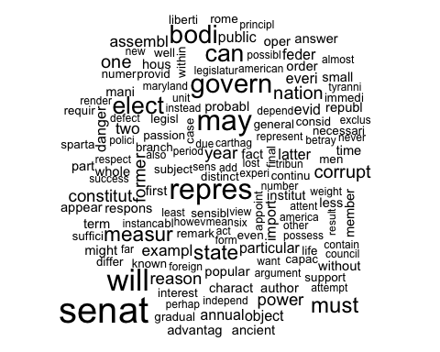

The below graph is a result of the essay text file noted with Hamilton as the author. We can see the most frequently used words are passiv, uncommerci, etc.

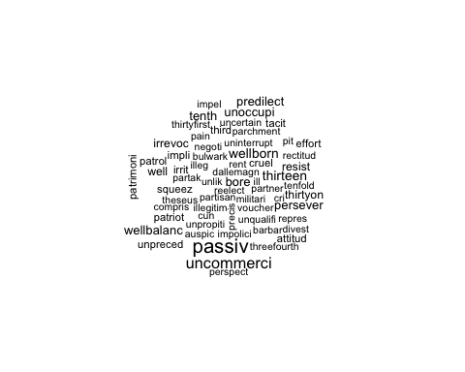

The below graph is a result of the essay text file noted with Madison as the author. We can see the most frequently used words are unimport, contract, cogent, etc.

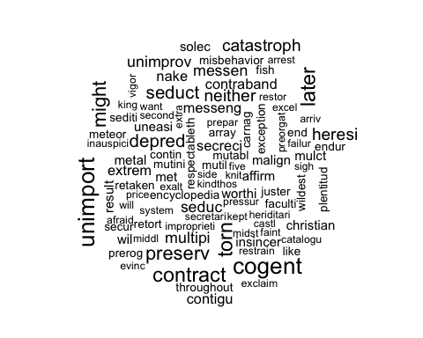

### Distance Metrics

A good distance metric helps in improving the performance of Classification, Clustering and, Information Retrieval process significantly. Below shows the researcher used three methods (Euclidean, Manhattan, and cosine) to perform distance metrics analysis. We can also conclude that cosine similarity works the best because the height in the cluster dendrogram is much smaller. In other words, the distance between those clusters was smaller. Normalized data and not normalized data are about the same because the size of the Papers are not significantly different.

|  |
| --- |
|  |
|  |
|  |
|  |

### Clustering

#### HAC

Hierarchical agglomerative clustering or HAC is a bottom-up hierarchical clustering. This hierarchy of clusters is represented as a tree (or dendrogram). The root of the tree is the unique cluster that gathers all the samples, the leaves being the clusters with only one sample. Below shown the HAC cluster dendrogram with three different methods – Euclidean similarity, Cosine Similarity, and Cosine Similarity Normalized.

By reviewing the graph, we can identify how the disputed items are closer to Hamilton or Madison. When they are closer, there are higher chances that the essays are from the same author. Since we determined the cosine similarity has a better result in the distance metric, we will focus on the HAC Cluster Dendrogram with Cosine Similarity graph and HAC Cluster Dendrogram with Cosine Similarity Normalized graph.

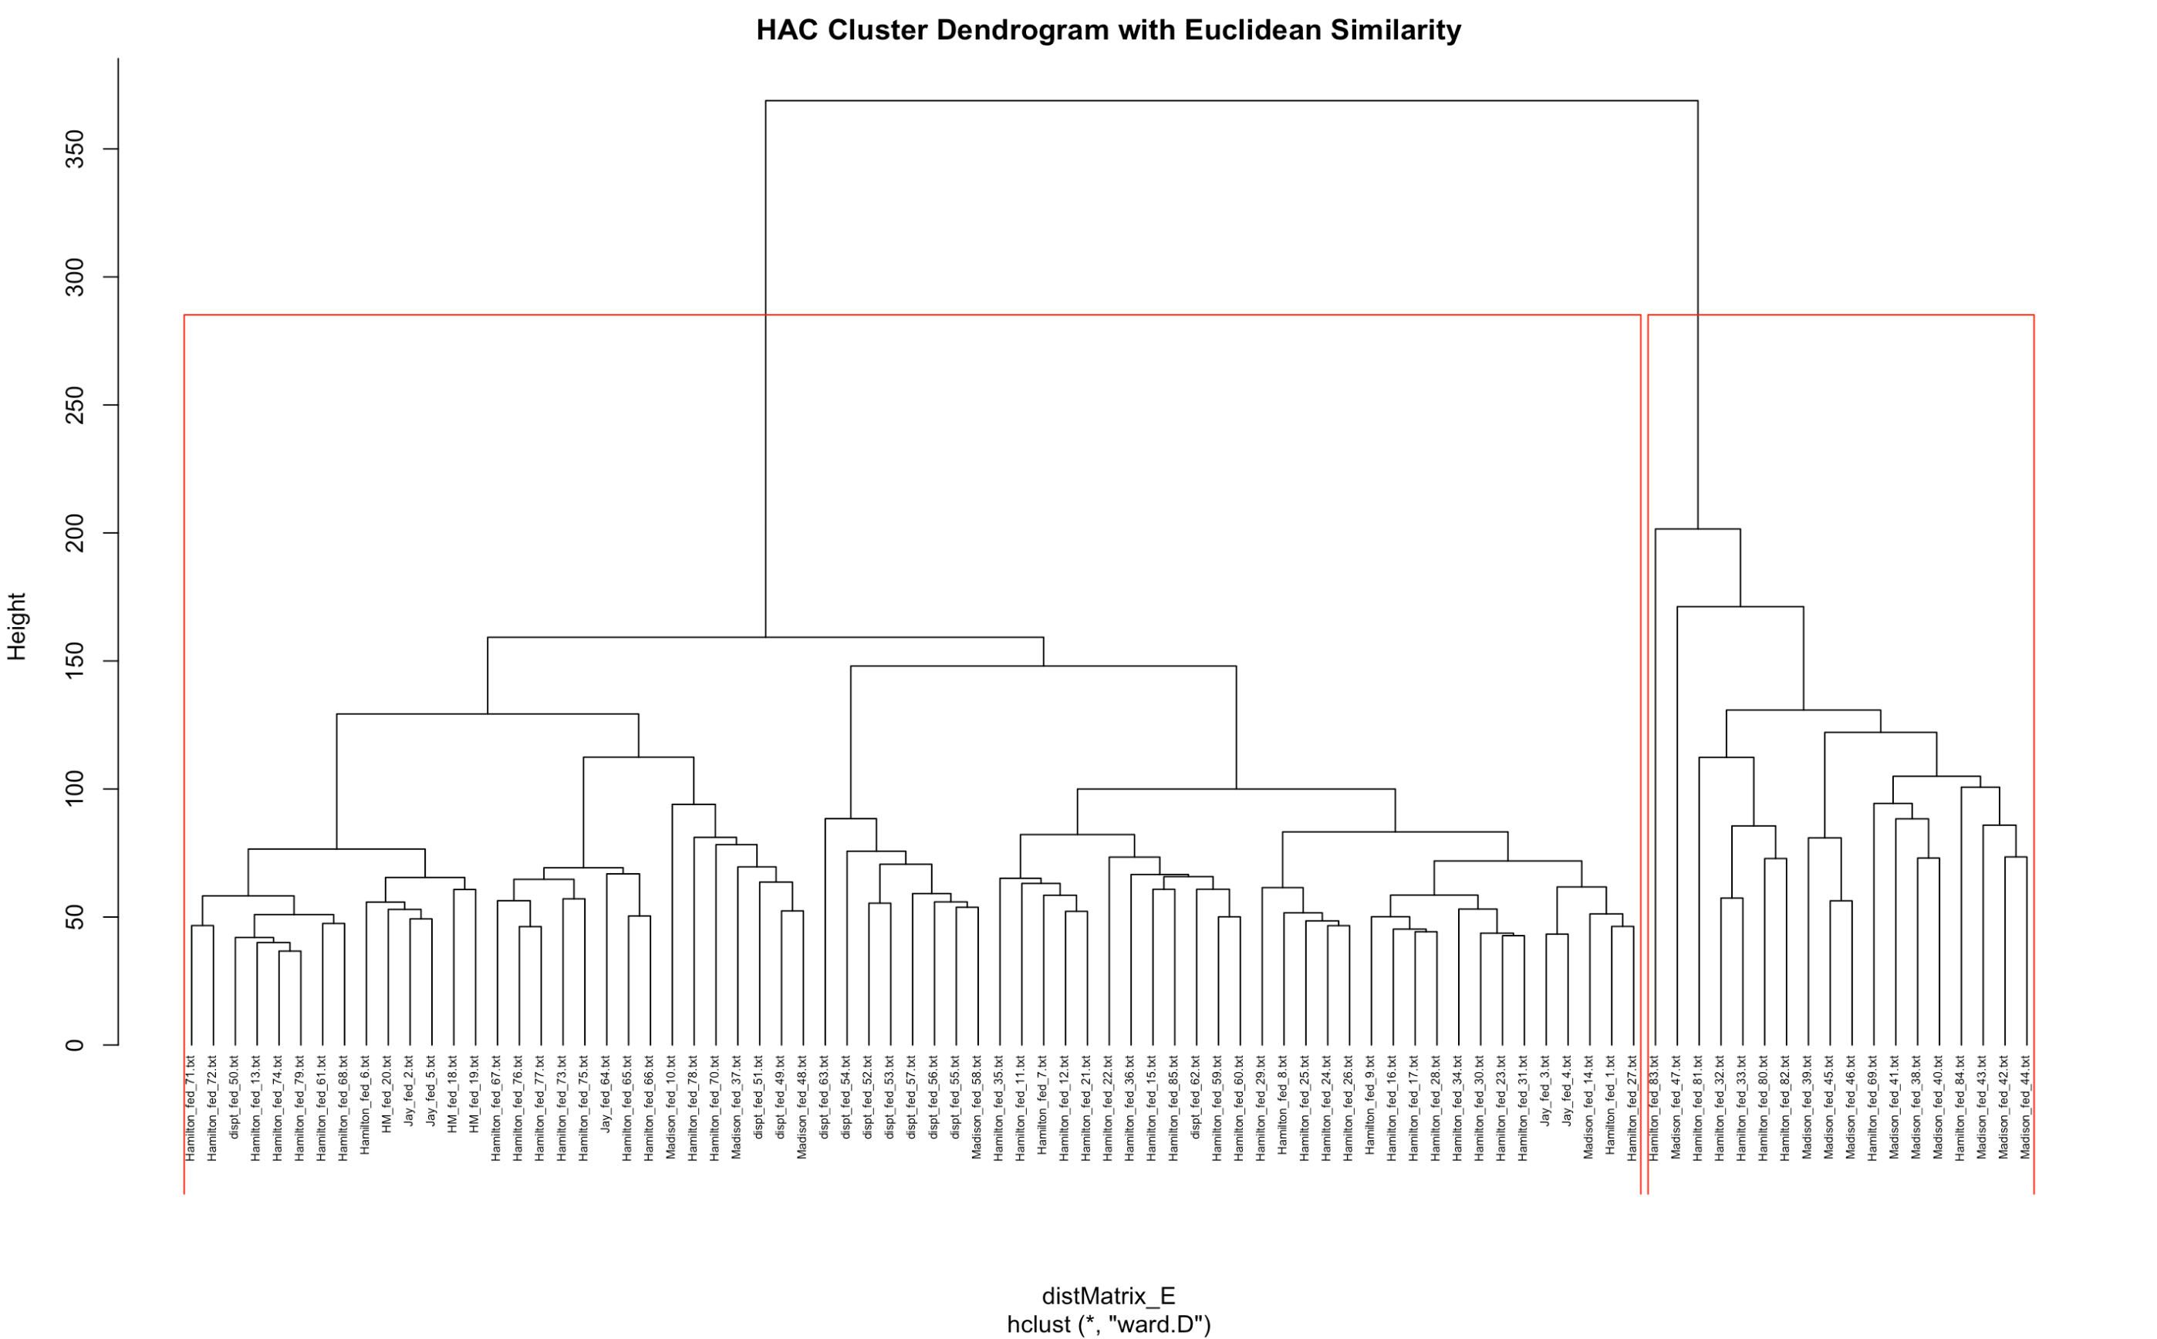

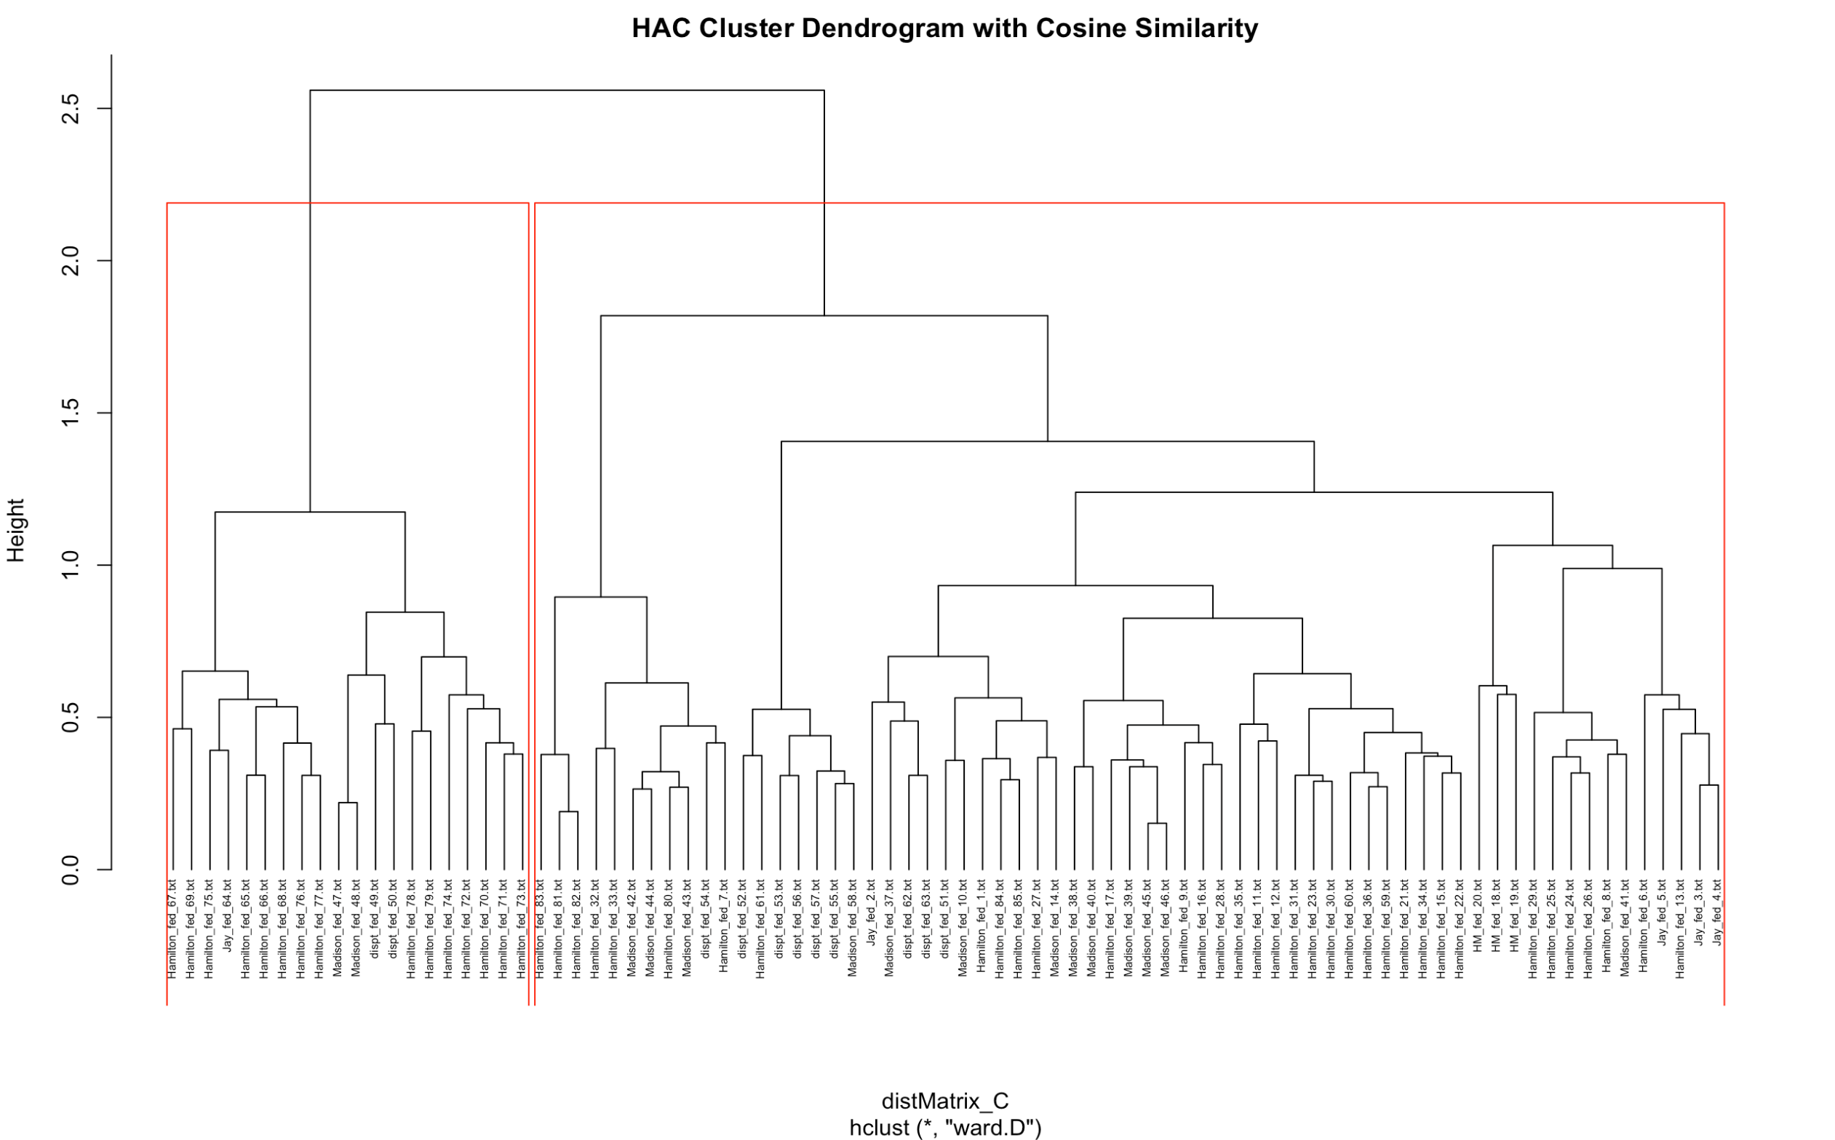

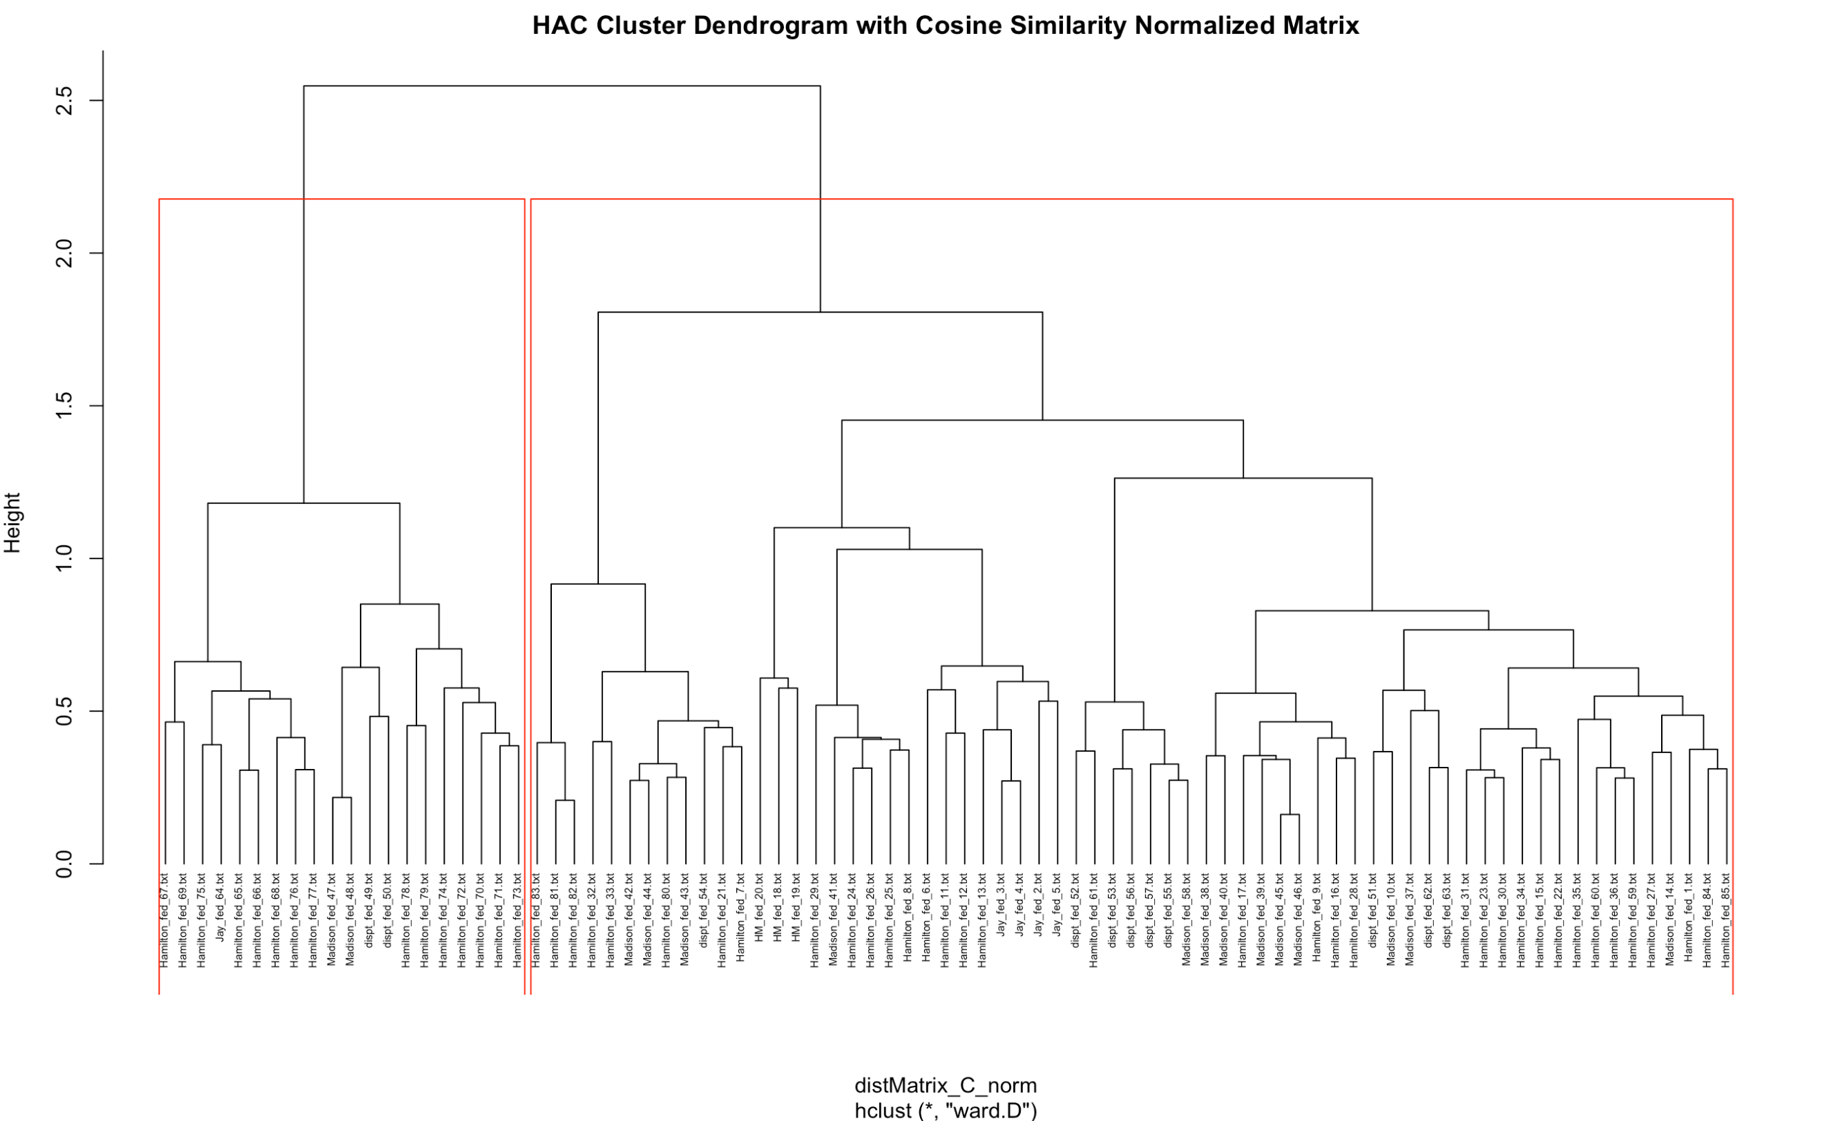

From the chart, we can see below close relationship among disputed items and other items. For those close together and under the same bracket, they are considered written by the same author.

#### K-mean Clustering

Below presents the result of K-mean clustering with four clusters. The stats are listed. However, the result is not easy to interpret.

List of 9

$ cluster : Named int [1:4900] 1 1 1 1 1 1 1 3 1 1 ...

..- attr(*, "names")= chr [1:4900] "abandon" "abat" "abb" "abet" ...

$ centers : num [1:4, 1:85] 7.51e-05 6.00e-03 1.81e-03 8.33e-03 1.08e-04 ...

..- attr(*, "dimnames")=List of 2

.. ..$ : chr [1:4] "1" "2" "3" "4"

.. ..$ : chr [1:85] "dispt_fed_49.txt" "dispt_fed_50.txt" "dispt_fed_51.txt" "dispt_fed_52.txt" ...

$ totss : num 0.384

$ withinss : num [1:4] 0.0768 0.0395 0.0945 0.0152

$ tot.withinss: num 0.226

$ betweenss : num 0.158

$ size : int [1:4] 4632 20 245 3

$ iter : int 3

$ ifault : int 0

- attr(*, "class")= chr "kmeans"

Below presents the correlation among objects using K-mean clustering. However, due to the high number of objects, it’s still not easy to interpret.

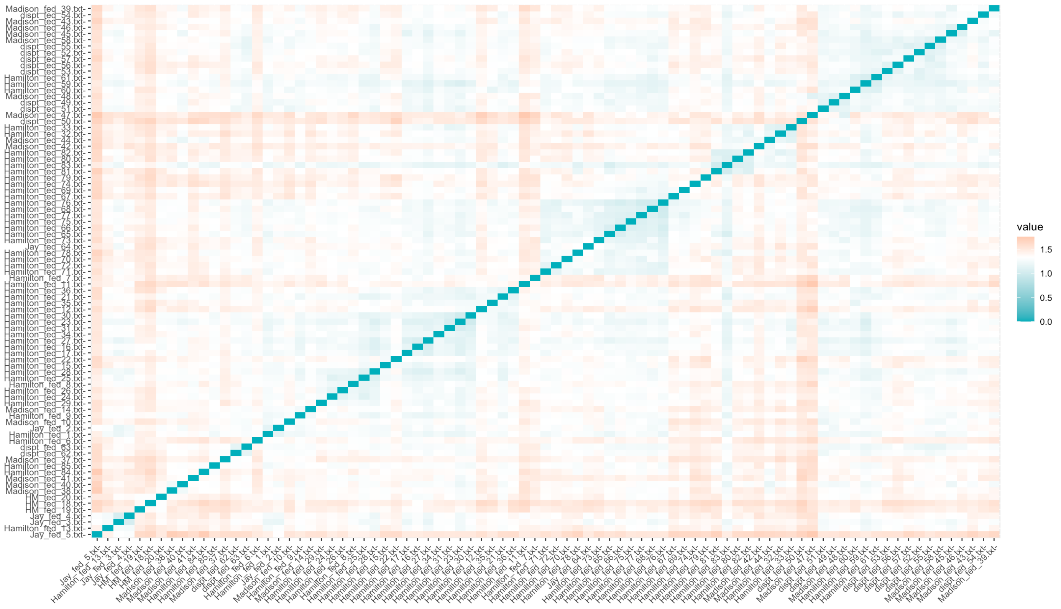

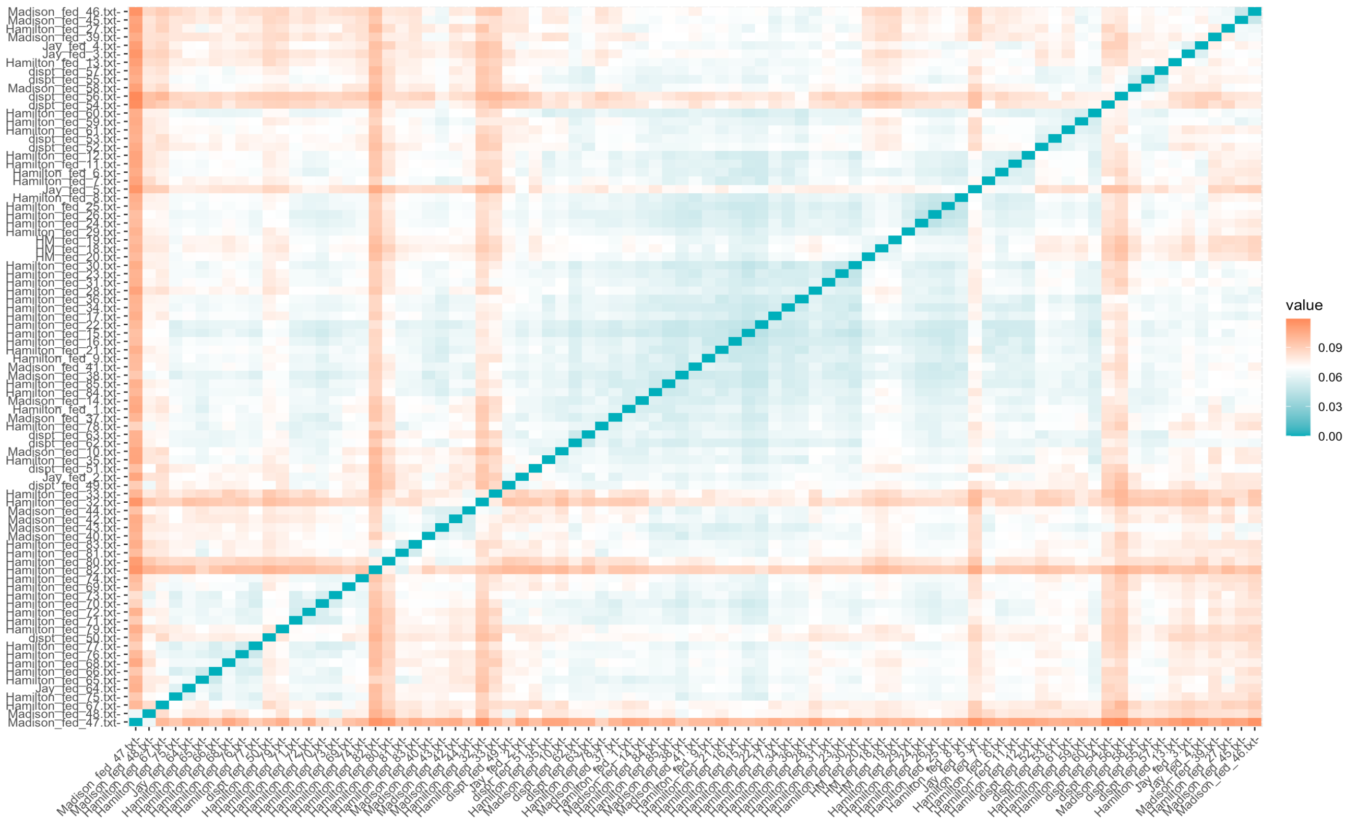

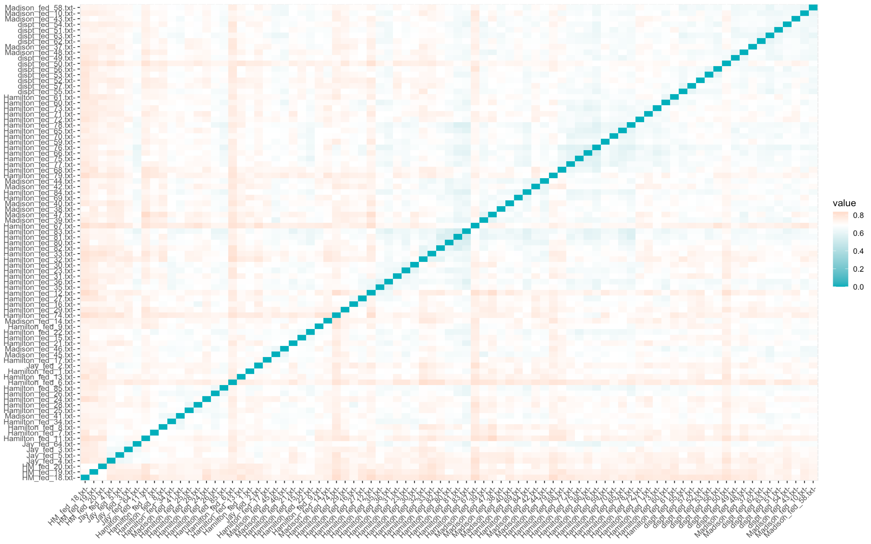

Below present four graphs with a different number of clusters ranging from two to four. The graph and result are better to interpret when the centroids are separable.

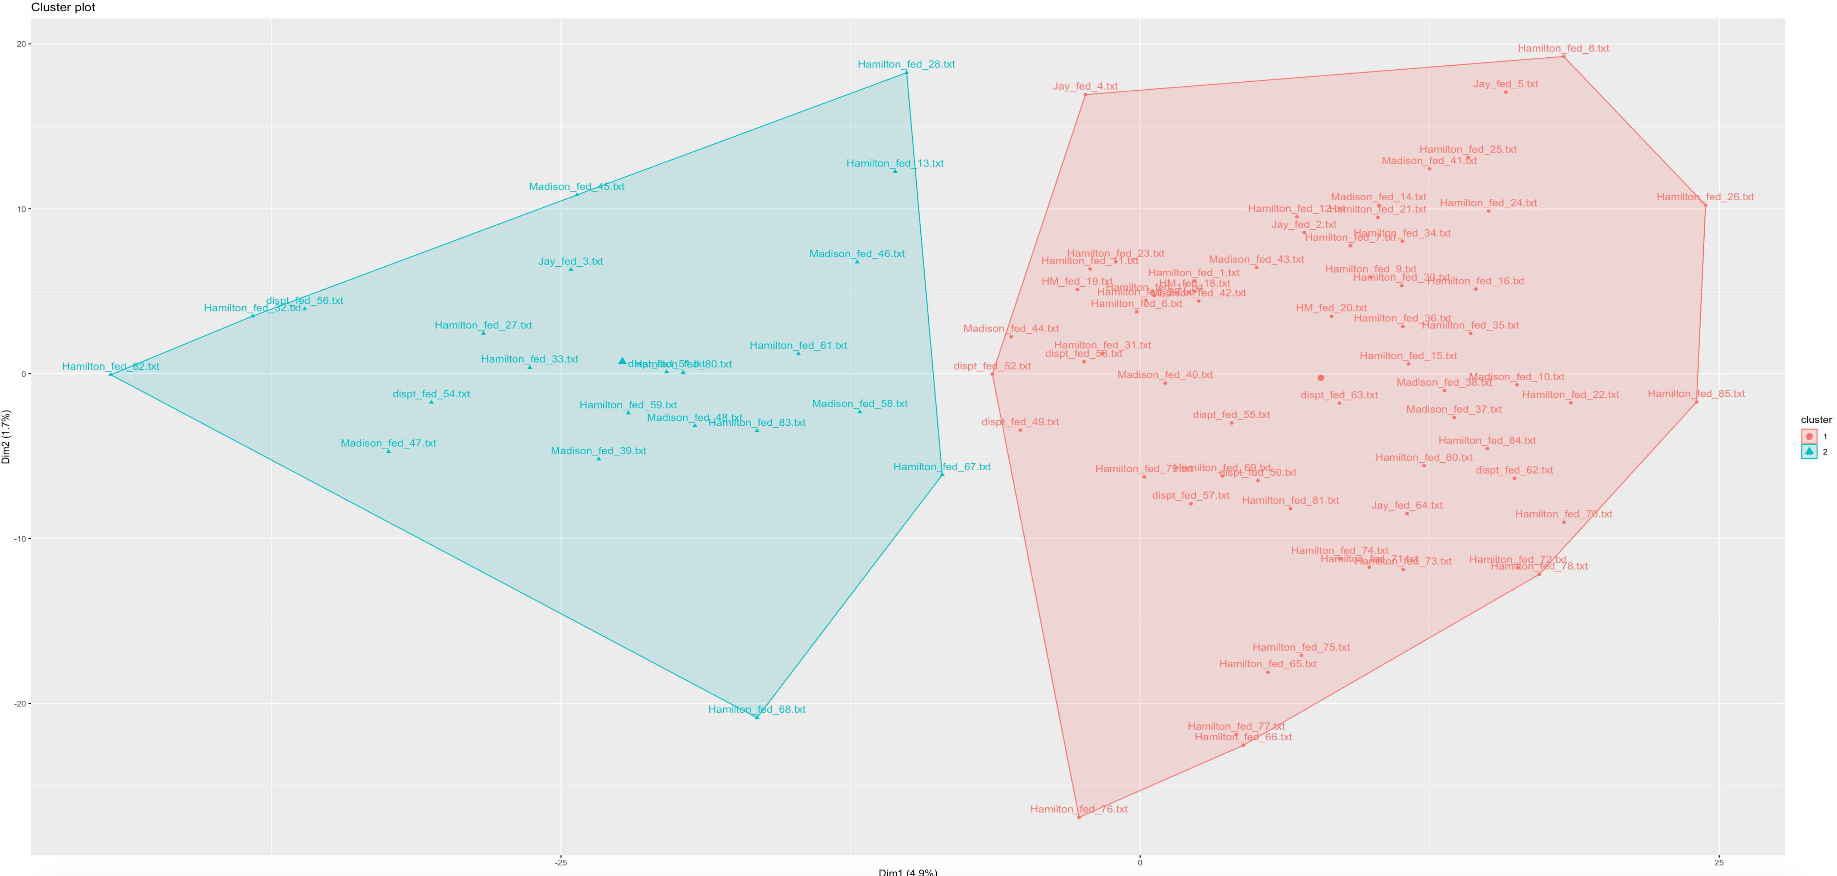

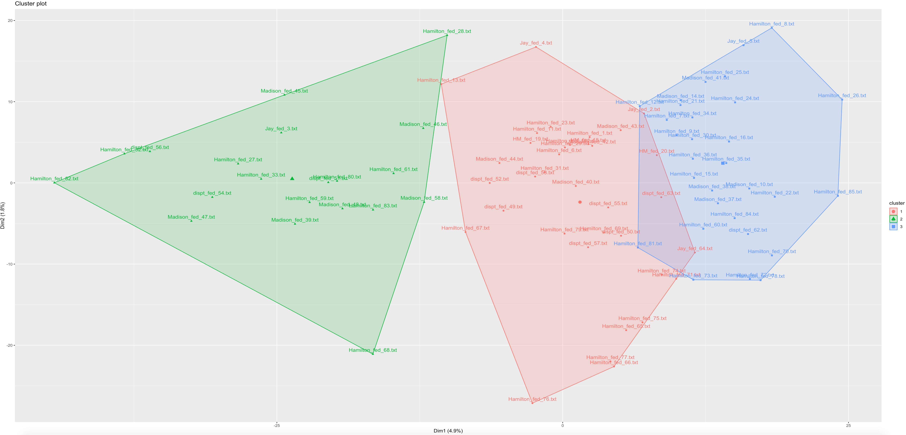

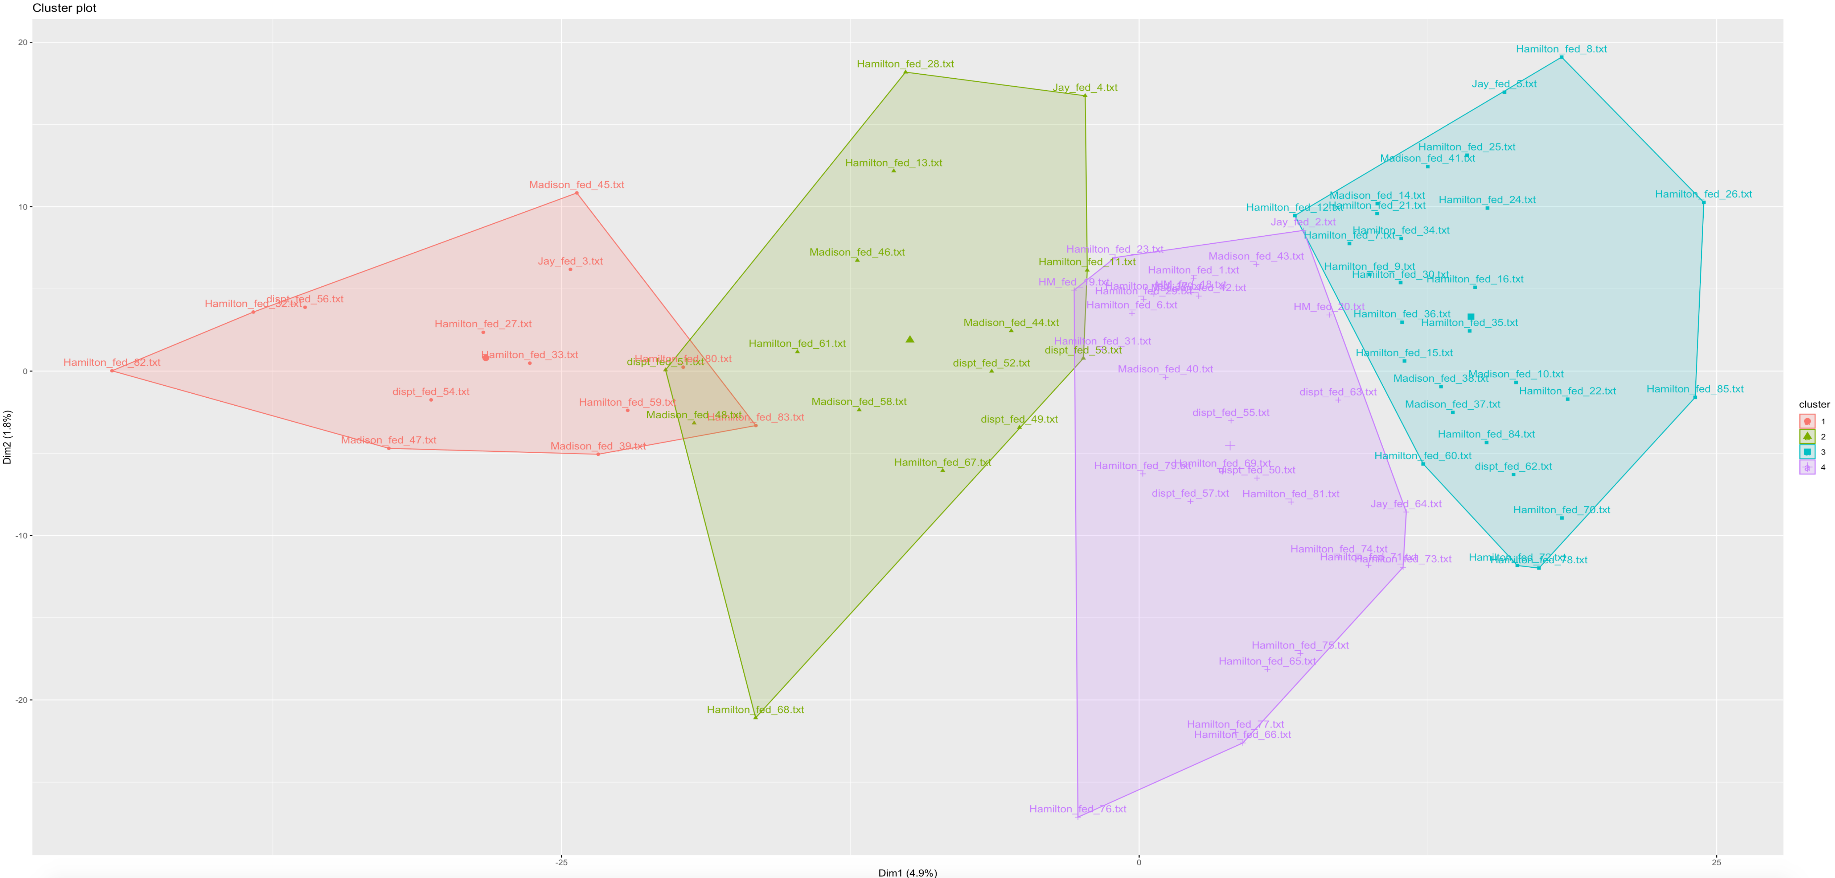

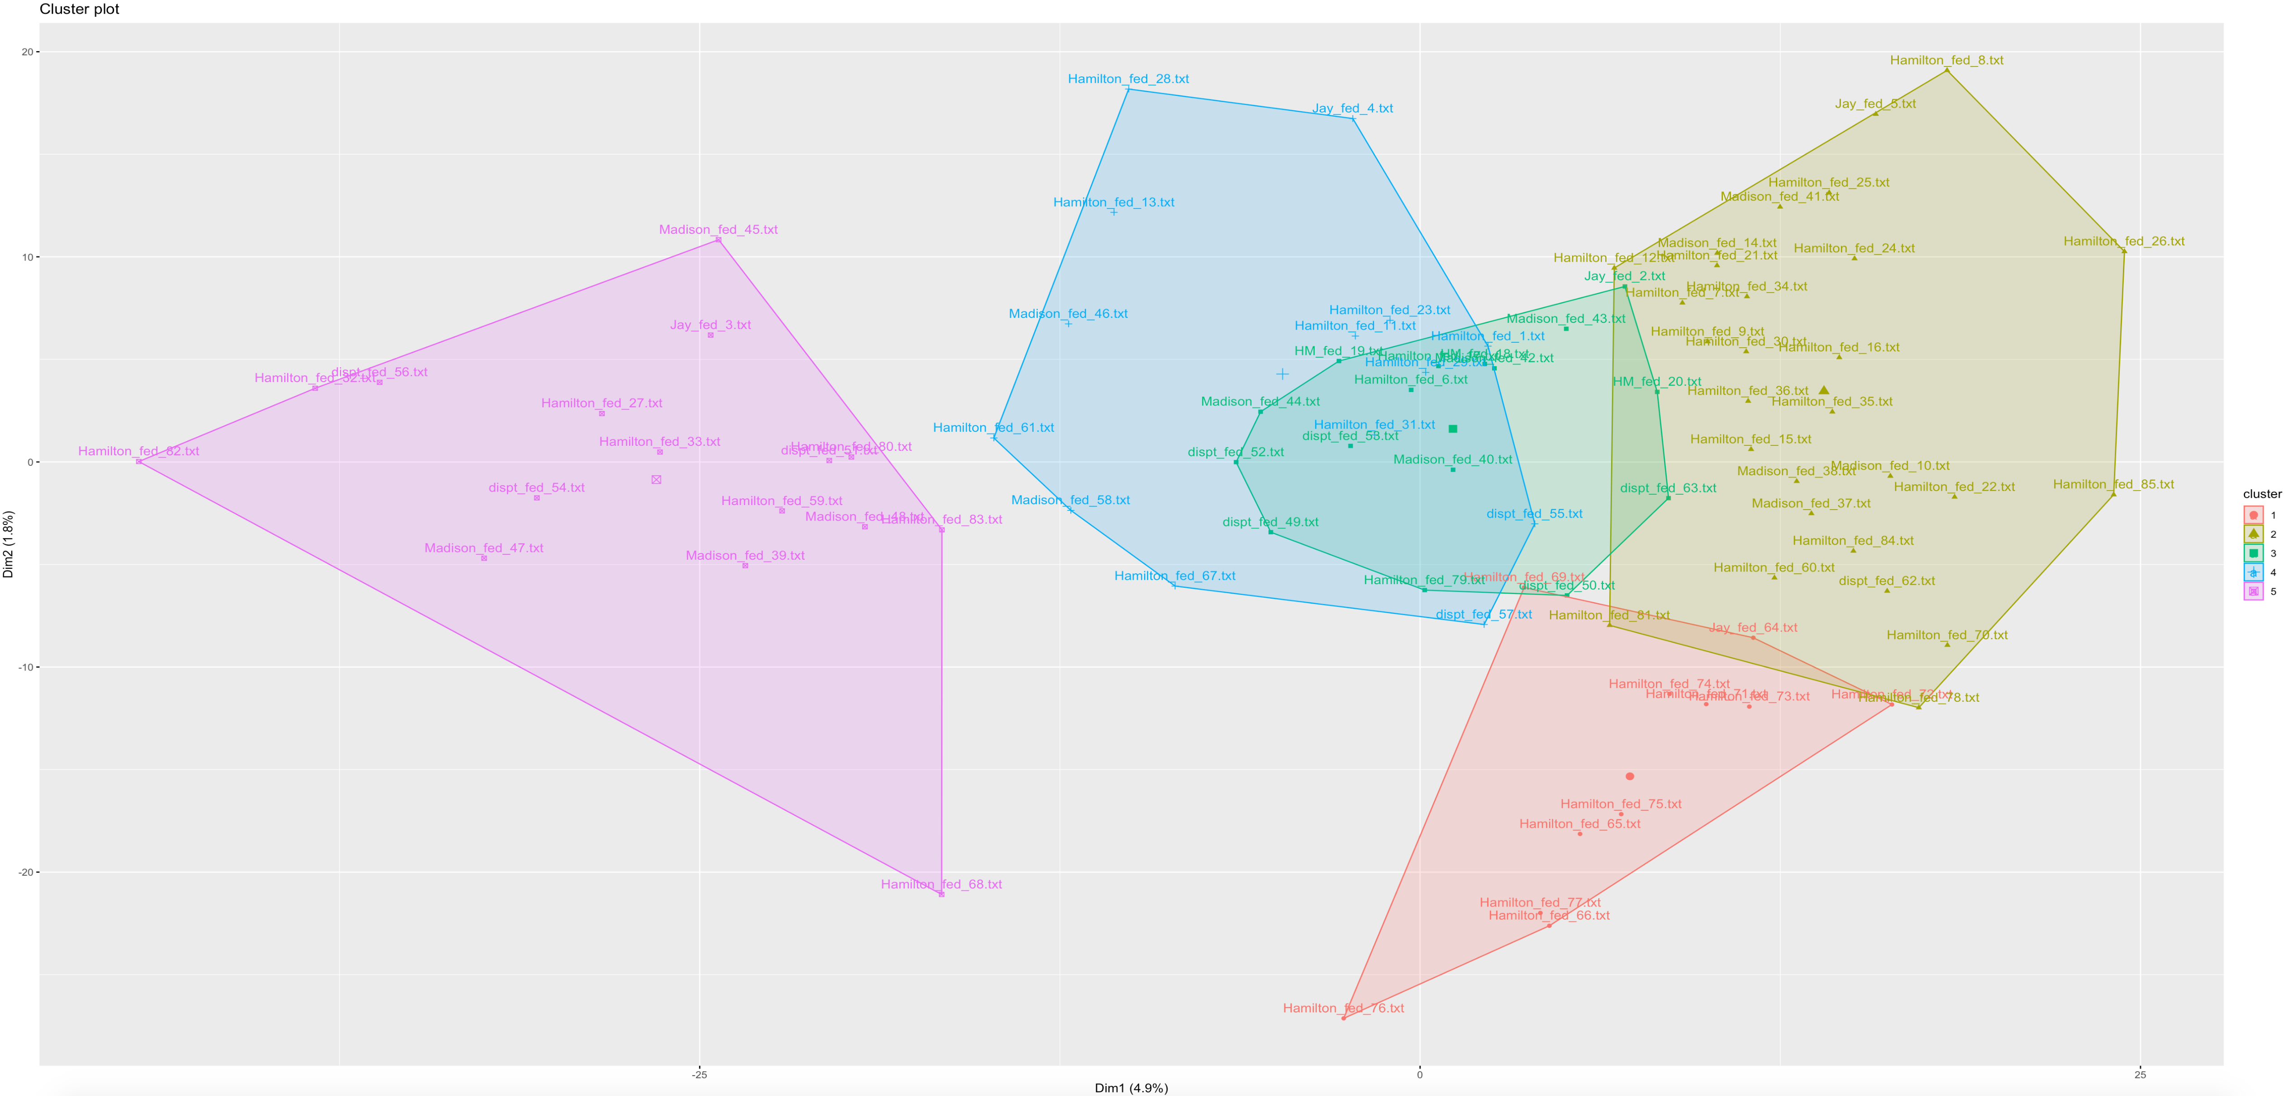

#### Expectation Maximization Clustering

The researcher used Weka to perform expectation maximization clustering. The researcher also found that it had the best result with four clusters. Below presents the result and visualization on how the data was clustered.

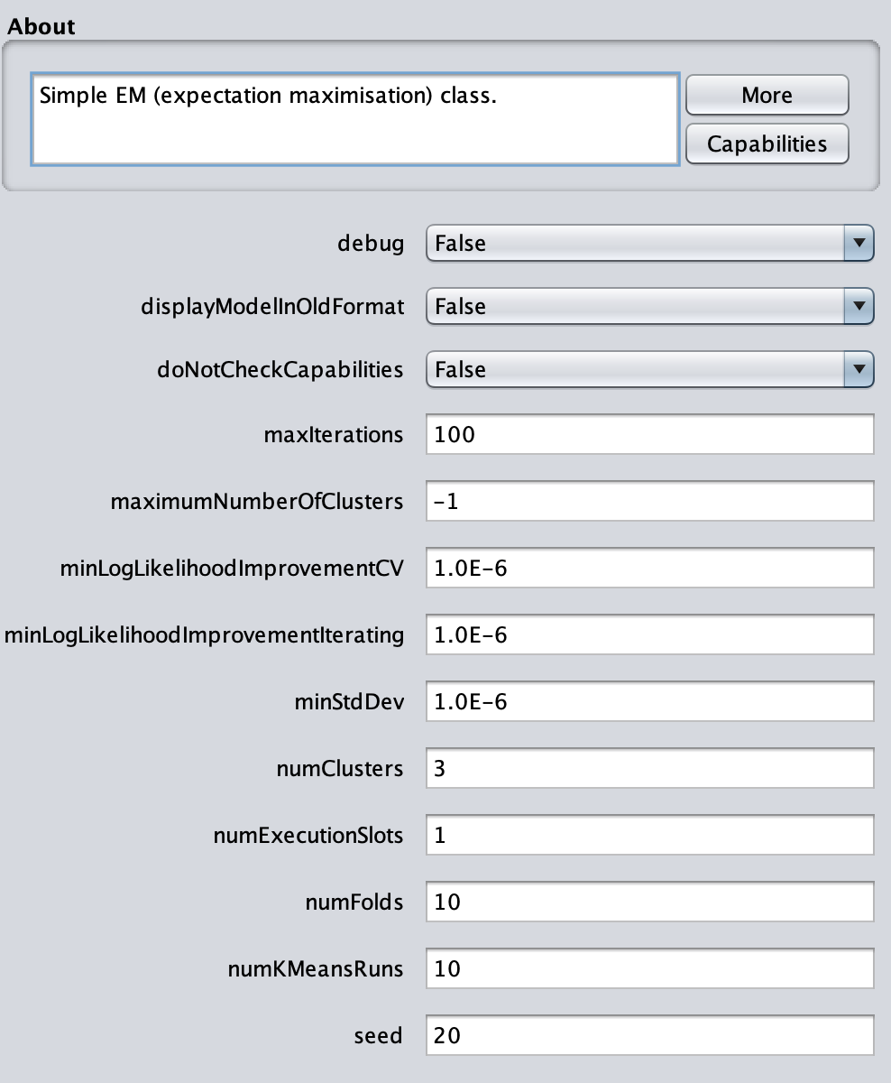

=== Model and evaluation on training set ===

Clustered Instances

0 6 ( 7%)

1 27 ( 32%)

2 21 ( 25%)

3 31 ( 36%)

Log likelihood: 167.99224

Class attribute: filename

Classes to Clusters:

0 1 2 3 <-- assigned to cluster

0 1 0 0 | dispt_fed_49.txt

0 1 0 0 | dispt_fed_50.txt

0 1 0 0 | dispt_fed_51.txt

0 1 0 0 | dispt_fed_52.txt

0 1 0 0 | dispt_fed_53.txt

0 1 0 0 | dispt_fed_54.txt

0 1 0 0 | dispt_fed_55.txt

0 1 0 0 | dispt_fed_56.txt

0 1 0 0 | dispt_fed_57.txt

0 1 0 0 | dispt_fed_62.txt

0 1 0 0 | dispt_fed_63.txt

0 0 0 1 | Hamilton_fed_1.txt

0 0 0 1 | Hamilton_fed_11.txt

0 0 0 1 | Hamilton_fed_12.txt

0 0 1 0 | Hamilton_fed_13.txt

0 0 0 1 | Hamilton_fed_15.txt

0 0 0 1 | Hamilton_fed_16.txt

0 0 1 0 | Hamilton_fed_17.txt

0 0 0 1 | Hamilton_fed_21.txt

0 0 0 1 | Hamilton_fed_22.txt

0 0 0 1 | Hamilton_fed_23.txt

0 0 0 1 | Hamilton_fed_24.txt

0 0 0 1 | Hamilton_fed_25.txt

0 0 0 1 | Hamilton_fed_26.txt

0 0 0 1 | Hamilton_fed_27.txt

0 0 0 1 | Hamilton_fed_28.txt

0 0 0 1 | Hamilton_fed_29.txt

0 0 0 1 | Hamilton_fed_30.txt

0 0 0 1 | Hamilton_fed_31.txt

0 0 0 1 | Hamilton_fed_32.txt

0 0 0 1 | Hamilton_fed_33.txt

0 0 0 1 | Hamilton_fed_34.txt

0 0 1 0 | Hamilton_fed_35.txt

0 0 0 1 | Hamilton_fed_36.txt

0 0 1 0 | Hamilton_fed_59.txt

0 0 1 0 | Hamilton_fed_6.txt

0 0 1 0 | Hamilton_fed_60.txt

0 0 1 0 | Hamilton_fed_61.txt

0 0 1 0 | Hamilton_fed_65.txt

0 0 1 0 | Hamilton_fed_66.txt

0 0 0 1 | Hamilton_fed_67.txt

0 0 1 0 | Hamilton_fed_68.txt

0 0 1 0 | Hamilton_fed_69.txt

0 0 1 0 | Hamilton_fed_7.txt

0 0 1 0 | Hamilton_fed_70.txt

0 0 1 0 | Hamilton_fed_71.txt

0 0 1 0 | Hamilton_fed_72.txt

0 0 1 0 | Hamilton_fed_73.txt

0 0 1 0 | Hamilton_fed_74.txt

0 0 1 0 | Hamilton_fed_75.txt

0 0 1 0 | Hamilton_fed_76.txt

0 0 1 0 | Hamilton_fed_77.txt

0 0 0 1 | Hamilton_fed_78.txt

0 0 0 1 | Hamilton_fed_79.txt

0 0 0 1 | Hamilton_fed_8.txt

0 0 0 1 | Hamilton_fed_80.txt

0 0 0 1 | Hamilton_fed_81.txt

0 0 0 1 | Hamilton_fed_82.txt

0 0 0 1 | Hamilton_fed_83.txt

0 0 0 1 | Hamilton_fed_84.txt

0 0 0 1 | Hamilton_fed_85.txt

0 0 1 0 | Hamilton_fed_9.txt

1 0 0 0 | HM_fed_18.txt

0 1 0 0 | HM_fed_19.txt

0 1 0 0 | HM_fed_20.txt

1 0 0 0 | Jay_fed_2.txt

1 0 0 0 | Jay_fed_3.txt

1 0 0 0 | Jay_fed_4.txt

1 0 0 0 | Jay_fed_5.txt

1 0 0 0 | Jay_fed_64.txt

0 1 0 0 | Madison_fed_10.txt

0 0 0 1 | Madison_fed_14.txt

0 1 0 0 | Madison_fed_37.txt

0 1 0 0 | Madison_fed_38.txt

0 1 0 0 | Madison_fed_39.txt

0 1 0 0 | Madison_fed_40.txt

0 1 0 0 | Madison_fed_41.txt

0 1 0 0 | Madison_fed_42.txt

0 1 0 0 | Madison_fed_43.txt

0 1 0 0 | Madison_fed_44.txt

0 1 0 0 | Madison_fed_45.txt

0 1 0 0 | Madison_fed_46.txt

0 1 0 0 | Madison_fed_47.txt

0 1 0 0 | Madison_fed_48.txt

0 1 0 0 | Madison_fed_58.txt

Cluster 0 <-- HM_fed_18.txt

Cluster 1 <-- dispt_fed_49.txt

Cluster 2 <-- Hamilton_fed_13.txt

Cluster 3 <-- Hamilton_fed_1.txt

Incorrectly clustered instances : 81.0 95.2941 %

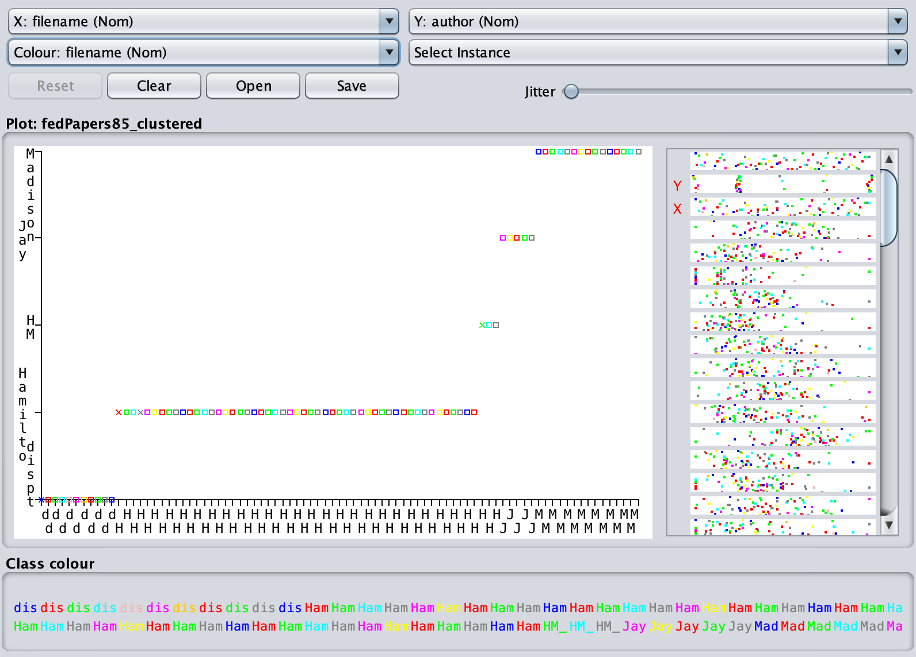

# Results

Distance Metrics:

Below summarizes the definition of Euclidean distance, Manhattan distance, and Cosine distance in distance metrics. We ran an analysis on all three types of distance metrics.

1. Euclidean Distance:

The Euclidean distance between two points in either the plane or 3-dimensional space measures the length of a segment connecting the two points. It is the most obvious way of representing the distance between two points.

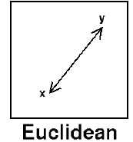

By running the stats of the distance measure, we can see the summary of distance among objects.

dispt_fed_49.txt dispt_fed_50.txt

dispt_fed_50.txt 45.23273

dispt_fed_51.txt 58.72819 64.61424

dispt_fed_52.txt 59.01695 54.96362

dispt_fed_53.txt 70.03571 64.11708

dispt_fed_54.txt 75.88149 70.42727

dispt_fed_55.txt 64.23395 58.56620

dispt_fed_56.txt 73.64102 64.44377

dispt_fed_57.txt 65.47519 65.36819

dispt_fed_62.txt 62.59393 63.71813

dispt_fed_63.txt 75.59100 80.44874

Hamilton_fed_1.txt 54.00926 48.32184

dispt_fed_51.txt dispt_fed_52.txt

dispt_fed_50.txt

dispt_fed_51.txt

dispt_fed_52.txt 65.39113

dispt_fed_53.txt 70.97887 55.40758

dispt_fed_54.txt 78.03204 69.08690

dispt_fed_55.txt 69.70653 56.15158

dispt_fed_56.txt 73.07530 62.94442

dispt_fed_57.txt 68.89122 57.35852

dispt_fed_62.txt 61.92738 62.71363

dispt_fed_63.txt 80.51708 70.33491

Hamilton_fed_1.txt 57.82733 58.05170

dispt_fed_53.txt dispt_fed_54.txt

dispt_fed_50.txt

dispt_fed_51.txt

dispt_fed_52.txt

dispt_fed_53.txt

dispt_fed_54.txt 73.51871

dispt_fed_55.txt 62.68174 69.87131

dispt_fed_56.txt 56.83309 62.80923

dispt_fed_57.txt 64.45153 70.33491

dispt_fed_62.txt 63.77304 71.34424

dispt_fed_63.txt 77.45321 90.73037

Hamilton_fed_1.txt 64.89992 69.44782

dispt_fed_55.txt dispt_fed_56.txt

dispt_fed_50.txt

dispt_fed_51.txt

dispt_fed_52.txt

dispt_fed_53.txt

dispt_fed_54.txt

dispt_fed_55.txt

dispt_fed_56.txt 55.45268

dispt_fed_57.txt 53.86093 60.51446

dispt_fed_62.txt 62.67376 66.79072

dispt_fed_63.txt 72.81483 82.64986

Hamilton_fed_1.txt 58.42089 62.54598

dispt_fed_57.txt dispt_fed_62.txt

dispt_fed_50.txt

dispt_fed_51.txt

dispt_fed_52.txt

dispt_fed_53.txt

dispt_fed_54.txt

dispt_fed_55.txt

dispt_fed_56.txt

dispt_fed_57.txt

dispt_fed_62.txt 63.28507

dispt_fed_63.txt 70.78842 66.18157

Hamilton_fed_1.txt 61.07373 59.52310

1. Manhattan Distance:

The distance between two points measured along axes at right angles. In a plane with p1 at (x1, y1) and p2 at (x2, y2), it is |x1 - x2| + |y1 - y2|.

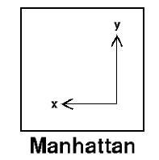

By running the stats of the distance measure, we can see the summary of distance among objects.

dispt_fed_49.txt dispt_fed_50.txt

dispt_fed_50.txt 816

dispt_fed_51.txt 1017 1041

dispt_fed_52.txt 1055 957

dispt_fed_53.txt 1193 1091

dispt_fed_54.txt 1108 1040

dispt_fed_55.txt 1156 1064

dispt_fed_56.txt 1047 927

dispt_fed_57.txt 1117 1127

dispt_fed_62.txt 1214 1190

dispt_fed_63.txt 1384 1408

Hamilton_fed_1.txt 1013 937

dispt_fed_51.txt dispt_fed_52.txt

dispt_fed_50.txt

dispt_fed_51.txt

dispt_fed_52.txt 1140

dispt_fed_53.txt 1252 1084

dispt_fed_54.txt 1185 1143

dispt_fed_55.txt 1213 1067

dispt_fed_56.txt 1124 1038

dispt_fed_57.txt 1258 1166

dispt_fed_62.txt 1203 1269

dispt_fed_63.txt 1423 1369

Hamilton_fed_1.txt 1102 1118

dispt_fed_53.txt dispt_fed_54.txt

dispt_fed_50.txt

dispt_fed_51.txt

dispt_fed_52.txt

dispt_fed_53.txt

dispt_fed_54.txt 1247

dispt_fed_55.txt 1197 1204

dispt_fed_56.txt 984 1003

dispt_fed_57.txt 1276 1231

dispt_fed_62.txt 1327 1298

dispt_fed_63.txt 1451 1546

Hamilton_fed_1.txt 1236 1151

dispt_fed_55.txt dispt_fed_56.txt

dispt_fed_50.txt

dispt_fed_51.txt

dispt_fed_52.txt

dispt_fed_53.txt

dispt_fed_54.txt

dispt_fed_55.txt

dispt_fed_56.txt 1039

dispt_fed_57.txt 1093 1120

dispt_fed_62.txt 1258 1191

dispt_fed_63.txt 1368 1403

Hamilton_fed_1.txt 1151 1078

dispt_fed_57.txt dispt_fed_62.txt

dispt_fed_50.txt

dispt_fed_51.txt

dispt_fed_52.txt

dispt_fed_53.txt

dispt_fed_54.txt

dispt_fed_55.txt

dispt_fed_56.txt

dispt_fed_57.txt

dispt_fed_62.txt 1307

dispt_fed_63.txt 1457 1370

Hamilton_fed_1.txt 1210 1263

1. Cosine Distance:

Cosine similarity is a metric used to measure how similar the documents are irrespective of their size. Mathematically, it measures the cosine of the angle between two vectors projected in a multi-dimensional space. The cosine similarity is advantageous because even if the two similar documents are far apart by the Euclidean distance (due to the size of the document), chances are they may still be oriented closer together. The smaller the angle, the higher the cosine similarity.

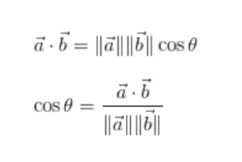

By running the stats of the distance measure, we can see the summary of distance among objects. The first statistic result is to apply cosine distance on original data. The second statistic result is to apply cosine distance on the normalized data.

cosine distance on original data

dispt_fed_49.txt dispt_fed_50.txt

dispt_fed_50.txt 0.4787923

dispt_fed_51.txt 0.4203566 0.5763611

dispt_fed_52.txt 0.5465990 0.5536806

dispt_fed_53.txt 0.5737372 0.4967776

dispt_fed_54.txt 0.6639084 0.6198161

dispt_fed_55.txt 0.5895771 0.5520229

dispt_fed_56.txt 0.7023536 0.5894541

dispt_fed_57.txt 0.5297737 0.5866360

dispt_fed_62.txt 0.4853514 0.5561181

dispt_fed_63.txt 0.4458337 0.5327095

Hamilton_fed_1.txt 0.5590265 0.5749124

dispt_fed_51.txt dispt_fed_52.txt

dispt_fed_50.txt

dispt_fed_51.txt

dispt_fed_52.txt 0.4866116

dispt_fed_53.txt 0.4778136 0.3213866

dispt_fed_54.txt 0.5658940 0.4975089

dispt_fed_55.txt 0.5241717 0.3999365

dispt_fed_56.txt 0.5372999 0.4571781

dispt_fed_57.txt 0.4694281 0.3683743

dispt_fed_62.txt 0.3818576 0.4472161

dispt_fed_63.txt 0.4727842 0.3668146

Hamilton_fed_1.txt 0.4088316 0.5368199

dispt_fed_53.txt dispt_fed_54.txt

dispt_fed_50.txt

dispt_fed_51.txt

dispt_fed_52.txt

dispt_fed_53.txt

dispt_fed_54.txt 0.4815945

dispt_fed_55.txt 0.3990633 0.4858878

dispt_fed_56.txt 0.3089753 0.3694124

dispt_fed_57.txt 0.3918477 0.4571646

dispt_fed_62.txt 0.3858965 0.4731606

dispt_fed_63.txt 0.4247931 0.5827869

Hamilton_fed_1.txt 0.4871156 0.5490465

dispt_fed_55.txt dispt_fed_56.txt

dispt_fed_50.txt

dispt_fed_51.txt

dispt_fed_52.txt

dispt_fed_53.txt

dispt_fed_54.txt

dispt_fed_55.txt

dispt_fed_56.txt 0.3351677

dispt_fed_57.txt 0.3091152 0.3663260

dispt_fed_62.txt 0.4235493 0.4493497

dispt_fed_63.txt 0.3930017 0.5030555

Hamilton_fed_1.txt 0.4891903 0.4985148

dispt_fed_57.txt dispt_fed_62.txt

dispt_fed_50.txt

dispt_fed_51.txt

dispt_fed_52.txt

dispt_fed_53.txt

dispt_fed_54.txt

dispt_fed_55.txt

dispt_fed_56.txt

dispt_fed_57.txt

dispt_fed_62.txt 0.3965606

dispt_fed_63.txt 0.3576741 0.3095453

Hamilton_fed_1.txt 0.4579186 0.4375370

cosine distance on the normalized data

dispt_fed_49.txt dispt_fed_50.txt

dispt_fed_50.txt 0.4827924

dispt_fed_51.txt 0.4213510 0.5766557

dispt_fed_52.txt 0.5514627 0.5563903

dispt_fed_53.txt 0.5779054 0.5013084

dispt_fed_54.txt 0.6637939 0.6299376

dispt_fed_55.txt 0.5954001 0.5557053

dispt_fed_56.txt 0.7024521 0.5940010

dispt_fed_57.txt 0.5249512 0.5877644

dispt_fed_62.txt 0.4914630 0.5581470

dispt_fed_63.txt 0.4580879 0.5390604

Hamilton_fed_1.txt 0.5594664 0.5758322

dispt_fed_51.txt dispt_fed_52.txt

dispt_fed_50.txt

dispt_fed_51.txt

dispt_fed_52.txt 0.4811365

dispt_fed_53.txt 0.4817163 0.3189064

dispt_fed_54.txt 0.5691914 0.4997042

dispt_fed_55.txt 0.5271478 0.4003687

dispt_fed_56.txt 0.5371422 0.4552061

dispt_fed_57.txt 0.4678030 0.3690229

dispt_fed_62.txt 0.3877660 0.4481082

dispt_fed_63.txt 0.4806482 0.3712855

Hamilton_fed_1.txt 0.4055004 0.5420774

dispt_fed_53.txt dispt_fed_54.txt

dispt_fed_50.txt

dispt_fed_51.txt

dispt_fed_52.txt

dispt_fed_53.txt

dispt_fed_54.txt 0.4860486

dispt_fed_55.txt 0.3966729 0.4809665

dispt_fed_56.txt 0.3112419 0.3667209

dispt_fed_57.txt 0.3935755 0.4558212

dispt_fed_62.txt 0.3926897 0.4771585

dispt_fed_63.txt 0.4261559 0.5839295

Hamilton_fed_1.txt 0.4910627 0.5561883

dispt_fed_55.txt dispt_fed_56.txt

dispt_fed_50.txt

dispt_fed_51.txt

dispt_fed_52.txt

dispt_fed_53.txt

dispt_fed_54.txt

dispt_fed_55.txt

dispt_fed_56.txt 0.3283400

dispt_fed_57.txt 0.3070508 0.3706902

dispt_fed_62.txt 0.4228952 0.4501058

dispt_fed_63.txt 0.3967400 0.5089835

Hamilton_fed_1.txt 0.4878348 0.5036593

dispt_fed_57.txt dispt_fed_62.txt

dispt_fed_50.txt

dispt_fed_51.txt

dispt_fed_52.txt

dispt_fed_53.txt

dispt_fed_54.txt

dispt_fed_55.txt

dispt_fed_56.txt

dispt_fed_57.txt

dispt_fed_62.txt 0.3987762

dispt_fed_63.txt 0.3639539 0.3151987

Hamilton_fed_1.txt 0.4631306 0.4472396

By reading the matrix, the researcher found the cosine distance has a better result as the distances are smaller and closer. While analyzing the matrix and the graphs, we can conclude the possible authors as below.

|  |  |
| --- | --- |
| NO | Possible Author |
| **49** | Madison |
| **50** | Madison |
| **51** | Madison |
| **52** | Hamilton |
| **53** | Madison |
| **54** | Hamilton |
| **55** | Madison |
| **56** | Madison |
| **57** | Madison |
| **62** | Madison |
| **63** | Madison |

HAC clustering:

Hierarchical clustering algorithms are either top-down or bottom-up. It Produces a set of nested clusters organized as a hierarchical tree. Bottom-up algorithms treat each document as a singleton cluster at the outset and then successively merge (or agglomerate) pairs of clusters until all clusters have been merged into a single cluster that contains all documents. Bottom-up hierarchical clustering is therefore called hierarchical agglomerative clustering or HAC. In this case, we use bottom-up hierarchical clustering for analysis.

By reviewing the graphs, we can conclude the possible authors for disputed essays. We also found that the essays noted authors to be Hamilton and Madison are closer to Hamilton’s essays.

1. Possible author from HAC clustering analysis.

|  |  |
| --- | --- |
| NO | Possible Author |
| **49** | Madison |
| **50** | Madison |
| **51** | Madison |
| **52** | Hamilton |
| **53** | Madison |
| **54** | Hamilton |
| **55** | Madison |
| **56** | Madison |
| **57** | Madison |
| **62** | Madison |
| **63** | Madison |

1. The essays noted Hamilton and Madison as authors (18, 19, and 20) are closer to Hamilton’s essays.

K-mean Clustering:

K-means is a centroid-based algorithm, or a distance-based algorithm, where we calculate the distances to assign a point to a cluster. In K-Means, each cluster is associated with a centroid. According to the graphs, the centroids are separable with four clusters. The researcher used two clusters, three clusters, fours clusters, and five clusters to analyze the data set. It was determined that four clusters had the best result as the centroids were separable. The possible authors for disputed essays can be concluded as below.

|  |  |
| --- | --- |
| NO | Possible Author |
| **49** | Madison |
| **50** | Hamilton |
| **51** | Hamilton |
| **52** | Hamilton |
| **53** | Madison |
| **54** | Hamilton |
| **55** | Madison |
| **56** | Hamilton |
| **57** | Hamilton |
| **62** | Hamilton |
| **63** | Madison |

Expectation Maximization:

The Expectation-Maximization (EM) algorithm is a way to find maximum-likelihood estimates for model parameters when your data is incomplete, has missing data points, or has unobserved (hidden) latent variables. It is an iterative way to approximate the maximum likelihood function. Based on the Weka analysis, we can conclude the result as below.

|  |  |
| --- | --- |
| NO | Possible Author |
| **49** | Madison |
| **50** | Madison |
| **51** | Madison |
| **52** | Madison |
| **53** | Madison |
| **54** | Madison |
| **55** | Madison |
| **56** | Madison |
| **57** | Madison |
| **62** | Madison |
| **63** | Madison |

The researcher ran several analyses with different cluster number and seeds. Four clusters and twenty seeds were considered the best result because the file name and authors seemed to line up pretty well. The estimate was very close. Surprisingly, the expectation maximization clustering showed that the authors for disputed essays should all be Madison.

# Conclusions

The goal of this research is to determine who the author might be for those disputed essays. It took many steps from data cleaning, transforming, vectorizing to applying clustering algorithms to the data frame. The researcher utilized many clustering algorithms including HAC, K-mean, and Expectation Maximization to determine the pattern and how Hamilton/Madison would choose words in writing essays. The researcher found it interesting that there wasn’t the best algorithm to use for the data set provided. After applying multiple algorithms and compared them with the distance matrix, we still can’t determine who the author really was. However, we have learned that clustering is a technique to estimate by grouping the target values, not to decide what the really answer could be.

# References

1. An Efficient k-Means Clustering Algorithm: Analysis and Implementation – Tapas Kanungo, David M. Mount, Nathan S. Netanyahu, Christine Piatko, Ruth Silverman, Angela Y. Wu - 2000
2. Development of a hybrid K-means-expectation maximization clustering algorithm - Adigun Abimbola Adebisi , Omidiora Elijah Olusayo , Olabiyisi Stephen Olatunde , Adetunji Abigael 'bola , Adedeji Olayinka Titilayo
3. Hierarchical clustering Algorithm - Seema B , Edward J , I-tsung Shen , Mnet Lab – 2003

Appendix A

|  |  |  |  |  |
| --- | --- | --- | --- | --- |
| **NO** | Title | Author | Publication | Date |
| **49** | [Method of Guarding Against the Encroachments of Any One Department of Government by Appealing to the People Through a Convention](https://www.congress.gov/resources/display/content/The+Federalist+Papers#TheFederalistPapers-49) | Hamilton or Madison | From the New York Packet | Tuesday, February 5, 1788 |
| **50** | [Periodic Appeals to the People Considered](https://www.congress.gov/resources/display/content/The+Federalist+Papers#TheFederalistPapers-50) | Hamilton or Madison | From the New York Packet | Tuesday, February 5, 1788 |
| **51** | [The Structure of the Government Must Furnish the Proper Checks and Balances Between the Different Departments](https://www.congress.gov/resources/display/content/The+Federalist+Papers#TheFederalistPapers-51) | Hamilton or Madison | From the New York Packet | Friday, February 8, 1788 |
| **52** | [The House of Representatives](https://www.congress.gov/resources/display/content/The+Federalist+Papers#TheFederalistPapers-52) | Hamilton or Madison | From the New York Packet | Friday, February 8, 1788 |
| **53** | [The Same Subject Continued: The House of Representatives](https://www.congress.gov/resources/display/content/The+Federalist+Papers#TheFederalistPapers-53) | Hamilton or Madison | From the New York Packet | Tuesday, February 12, 1788 |
| **54** | [The Apportionment of Members Among the States](https://www.congress.gov/resources/display/content/The+Federalist+Papers#TheFederalistPapers-54) | Hamilton or Madison | From the New York Packet | Tuesday, February 12, 1788 |
| **55** | [The Total Number of the House of Representatives](https://www.congress.gov/resources/display/content/The+Federalist+Papers#TheFederalistPapers-55) | Hamilton or Madison | From the New York Packet | Friday, February 15, 1788 |
| **56** | [The Same Subject Continued: The Total Number of the House of Representatives](https://www.congress.gov/resources/display/content/The+Federalist+Papers#TheFederalistPapers-56) | Hamilton or Madison | From the New York Packet | Tuesday, February 19, 1788 |
| **57** | [The Alleged Tendency of the Plan to Elevate the Few at the Expense of the Many Considered in Connection with Representation](https://www.congress.gov/resources/display/content/The+Federalist+Papers#TheFederalistPapers-57) | Hamilton or Madison | From the New York Packet | Tuesday, February 19, 1788 |
| **62** | [The Senate](https://www.congress.gov/resources/display/content/The+Federalist+Papers#TheFederalistPapers-62) | Hamilton or Madison | For the Independent Journal | - - |
| **63** | [The Senate Continued](https://www.congress.gov/resources/display/content/The+Federalist+Papers#TheFederalistPapers-63) | Hamilton or Madison | For the Independent Journal | - - |